**E.R.A (Event Registration Application) V 2.0**

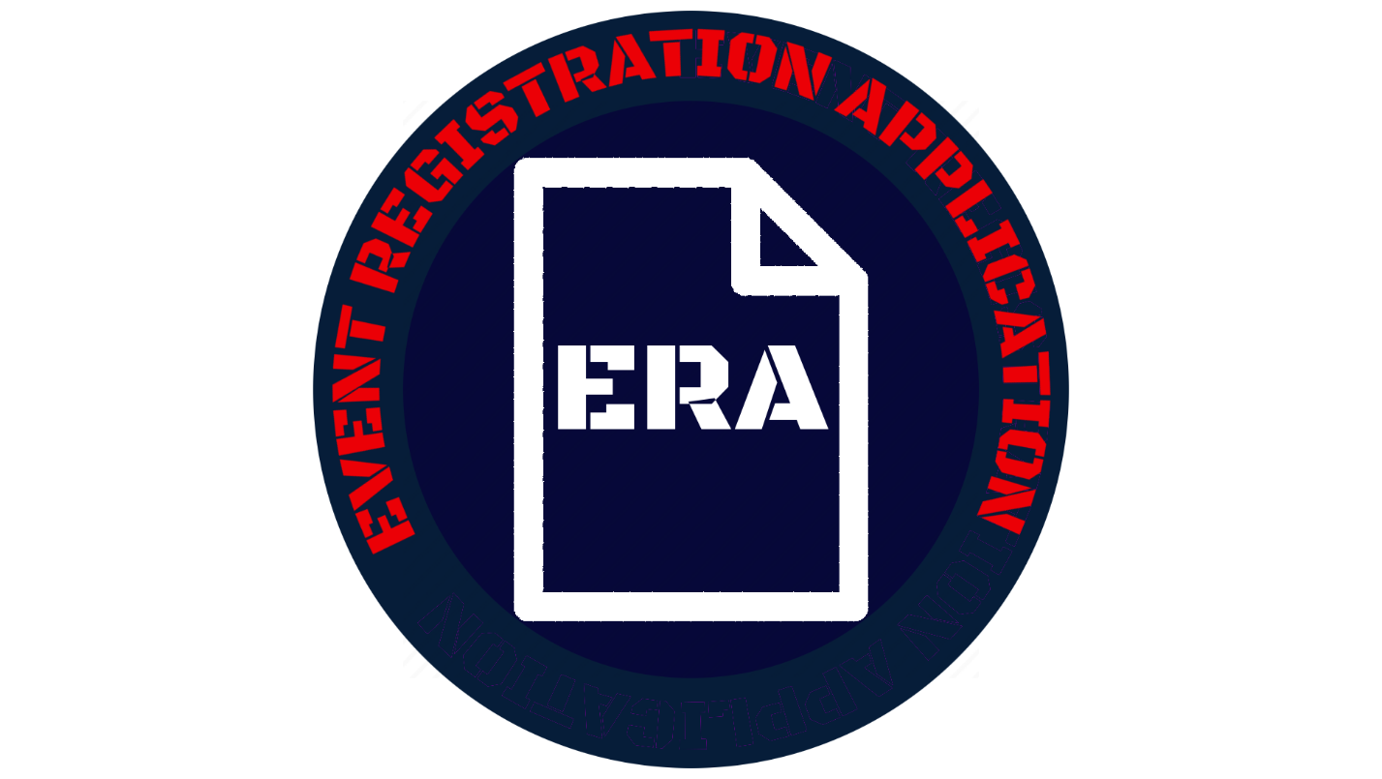

**SUMMARY**

The Event Registration Application Version 2 or ERA V 2.0 is the next iteration of the dynamic tool that organizers across the US Airforce can use to create and manage events using SharePoint Online. It adds commonly requested features and enhancements to improve ERA and refine it into a superior tool.

* Created by AFGSC/DSK at Barksdale AFB.
* Designed to meet the need for a new Event Registration site after SharePoint Tech support announced the decomissioning of the original without a backup tool.
* Not for creating a replacement to address the needs of a particular event registration site, but to create a single tool that was built to address the needs of *any* event registration site so that it can be shared Airforce wide.
* Limitied level of customizeability for personell with software development background. View settings must be done through CSS (Cascading Style Sheets) on modern site.
* Designed to automate as many actions with creating and registering for events as possible such as email notifcations and self-signup.
* Designed to be as intuitive as possible with controls and features that users will be able to learn by using the application and referring to documnetation.

**DISCLAIMER:**

For any issues with installation or use, please contact your SCA Admin first before contacting AFGSC/DSK. ERA has been thouroghly tested and certain features or functions may vary by individual site settings where installed. You can contact us if needed at <AFGSC.KM.Workflow@us.af.mil>

The following page is a credits section that lists the AFGSC/DSK KM shop as the development shop for ERA V 2.0, the team members in the shop who developed it, and their respective roles in the creation of this app. It is in no way meant to be a contact-support index to be used if any problems are found with ERA.

The screenshots used for walkthroughs and setups in this document feature purely “dummy” data to demo events and in no way represent actual events or any of their accompanying information used in actual service.

AFGSC/DSK

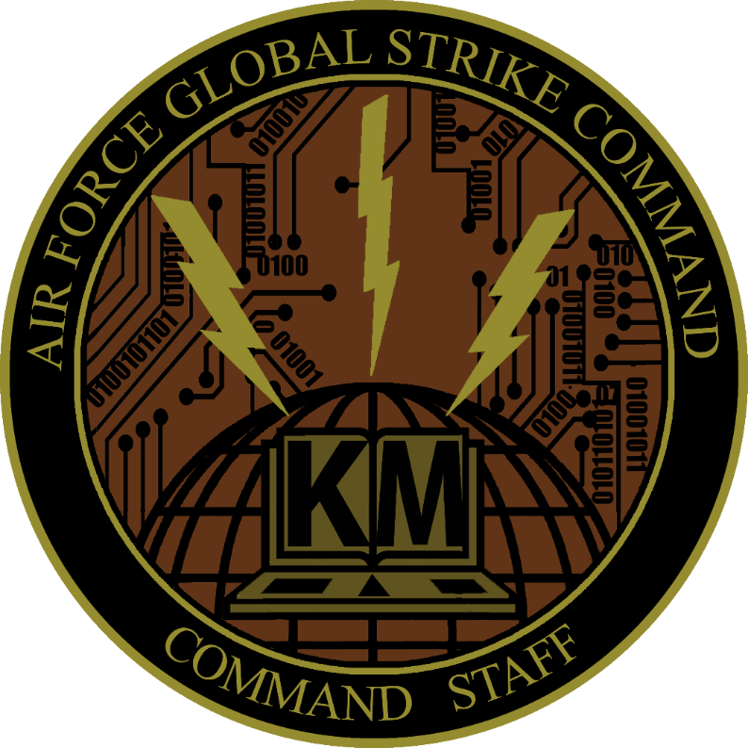

DEVELOPMENT TEAM

|  |  |
| --- | --- |
| Product Owner | Carl Canuel SrA, AFGSC |
| Lead/Developer | Josh Gardiner, Peerless Technologies |
| Support Developer | Stephen Burtrum SSgt, AFGSC |

## ATTENDEES

1. Type title or date into Search to find a particular event

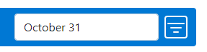

1. View an event's details by clicking the View icon to the left of Title.

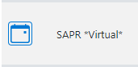

1. Register or unregister for an event by clicking on their respective buttons. Click on the blue icon with “+” to register for a course. Click on the red icon with “-“to unregister for a course.

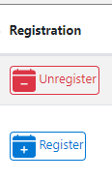

1. If registered for an event, click the blue icon with the arrow to add the event to the Outlook calendar.



1. If a class is full, add yourself to the waitlist by clicking the blue button with the person and the “+”. You will now be able to register for the course if someone unregisters and a spot opens.

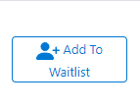

1. To remove yourself from the waitlist, click the red button with the person and the “x”

